EXPERIMENT: COLUMN CHROMATOGRAPHY FORENSICS

Objectives
Before doing this lab you should understand:
- The concept of a mixture.
- The concept of a solution.
- The difference between a homogenous mixture (i.e. a solution) and a heterogeneous mixture.
After doing this lab you should be able to:
- Explain the difference between chromatography and other separation methods.
- Separate the components of a given solution based on polarity.

Introduction
Distillation can separate a mixture based on boiling points, centrifuging can separate a mixture based on particle mass using high-speed rotation, extraction can separate a mixture based on solubility, and filtration is effective for removing particles or other un-dissolved components of a heterogeneous mixture. However, others means may be necessary to separate out dissolved components of a homogeneous mixture. Chromatography is used to separate homogeneous mixtures into their component parts using a stationary and mobile phase. What makes grape-flavored Kool-Aid purple? Food dye, of course. Color additives are common in the foods on supermarket shelves. The ingredients of grape Kool-Aid® include sugar, citric acid, ascorbic acid, red dye, and blue dye. We will separate the dyes in Kool-aid using column chromatography. Similar processes are used to separate blood into its components to compare a suspect’s blood to the blood found at a crime scene.

As water is polar, it attracts the OH group on alcohols. Because of the strength of the attraction to an OH group, the first three alcohols (methanol, ethanol and propanol) are completely miscible (forms a homogeneous mixture). They dissolve in water in any amount. Red 40 dye is somewhat more polar than Blue 1 dye. Each molecule will have a similar amount of charge from ionization, but since Blue 1 is a larger molecule, the resulting charge will be spread out over a larger molecule. Non-polar molecules spend very little time adhering to a polar solvent and therefore will stay in the non-polar column. The 8.5% isopropyl alcohol solution is slightly polar. As the dilute alcohol solvent is passed through the column, the red dye, which is also slightly polar, is more attracted to the solvent than it is to the column. The blue dye, however, is less polar than the red dye and is still attracted more strongly to the column. The higher percentages of isopropyl alcohol solution are less polar than the 8.25% isopropyl alcohol solution.
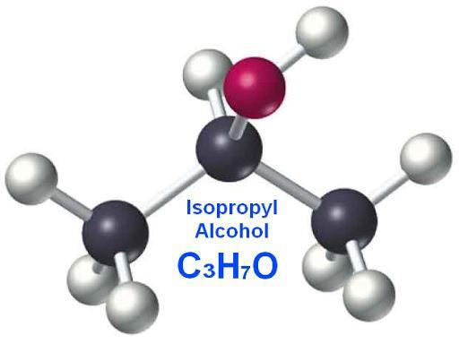
Water H₂O
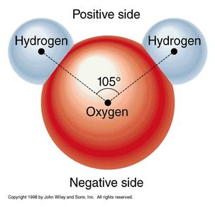
Materials
• 4 isopropyl alcohol sample bottles (8.25%, 17.5%, 35%, 70%)
• One distilled water sample bottle
• One waste beaker
• Kool-Aid sample
• One Syringe with column
• Five sample test tubes

Roles
a. Data Recorder – Records all data and observations
b. Solution Adder – Adds the solutions to the top of the column with a syringe
c. Solution Manager – Prepares solution for Solution Adder; Keeps track of what solution to add next.
d. Column Manager – Keeps the column in proper position and over the correct tube number while pushing.
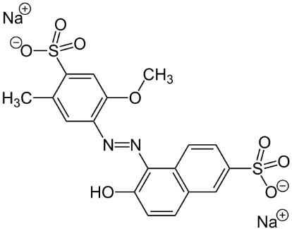

Blue 1 (less polar) Red 40 (more polar)

Procedure

- Obtain the materials for the experiment.
- Fill the syringe full of 70% alcohol.
- Attach the syringe to the top of the column.
- Push the plunger in SLOWLY. The alcohol will drip out into the waste beaker. If liquid remains on top of the column, remove the syringe and pull the plunger out farther. Reattach to push the remaining liquid through into the waste beaker.
- Repeat steps 2-4 using a syringe full of distilled water to complete the rinsing process.
- Add 1 mL of your Kool-aid sample and let it sink down into the column. Use the plunger to push it along SLOWLY like you did in Step 4. Some may drip into the waste beaker.
- Add a full syringe of distilled water to the column. SLOWLY push the water through the column with the syringe into bottle labeled SAMPLE #1

- Add a full syringe of 8.25% alcohol to the column. SLOWLY push the alcohol through the column with the syringe into bottle labeled SAMPLE #2
- Add a full syringe of 17.5% alcohol to the column. SLOWLY push the alcohol through the column with the syringe into bottle labeled SAMPLE #3
- Add a full syringe of 35% alcohol to the column. SLOWLY push the alcohol through the column with the syringe into bottle labeled SAMPLE #4
- Add a full syringe of 70% alcohol to the column. SLOWLY push the alcohol through the column with the syringe into bottle labeled SAMPLE #5.
- Your teacher has the results of the crime scene sample. Compare your results with the crime scene sample. Does your sample match?

Results
The 70% isopropyl alcohol and water were used to rinse the column by slowly forcing it with the syringe’s plunger. Then, 1 mL of Kool-Aid was added. A syringe full of distilled water was passed through the syringe into the column. The solution that left the column into the sample 1 bottle was … Finish this with your observations.

_____________________________________________________________________________________________

_____________________________________________________________________________________________

_____________________________________________________________________________________________

_____________________________________________________________________________________________

_____________________________________________________________________________________________

_____________________________________________________________________________________________

Conclusion
Answer the following questions.

1. Explain the difference between a homogenous mixture and a heterogeneous mixture.

2. Explain the difference between chromatography and other separation methods.

3. The stationary phase column is non-polar. Rank the mobile phases used to separate the Kool-Aid in terms of their polarity from the least to the most polar (water, and 8.25%, 17.5%, 35%, 70% isopropyl alcohol).

4. The ingredients of grape Kool-Aid are sugar, citric acid, ascorbic acid, blue dye, and red dye. Water followed by 8.5%, 17.5%, 35.5%, and 70% isopropyl alcohol were passed through the column in that order. Based on what you know about the polarity of the solutions, explain what you observed.
TEACHER GUIDE: COLUMN CHROMATOGRAPHY

Materials Needed
• One Sep-Pak@ C-18 cartridge (column) for each student group
• Kool-Aid@ - different kinds and additives for each suspect
• water
• rubbing alcohol (isopropyl alcohol, 70% by volume, with no color or added scent)
• the following volumetric measures:
25 mL graduated cylinder (for preparation)
10 mL graduated cylinder for each student group
• 6 small vials or test tubes with labels for each student group
• container to collect liquid waste
• one 10 to 50 mL syringe with male Luer@ tip for each student group
• six 50 to l00 mL plastic bottles for alcohol solutions and water

Kool-aid Preparation:
Prepare suspects Kool-aid samples in the following way:
1. Full packet of grape kool-aid with 300 mL of water
2. Full packet of black cherry kool-aid with 200 mL water
3. Full packet of orange kool-aid with 150 mL water + 50 mL of Solution #1
4. Full packet of berry blue kool-aid with 150 mL water + 50 mL of Solution #1

Alcohol Solution Preparation:
Prepare the following alcohol solutions using rubbing alcohol you buy at the drug store and distilled water.
1. Prepare 40 mL of a 35% isopropyl alcohol solution (20 mL of rubbing alcohol and 20 mL of water). Put the solution into a bottle and label it "35% isopropyl alcohol."
2. Prepare 40 mL of a 17.5% isopropyl alcohol solution (10 mL of rubbing alcohol and 30 mL of water). Put the solution into a bottle and label it "17.5% isopropyl alcohol."
3. Prepare 40 mL of an 8.25% isopropyl alcohol solution (5 mL of rubbing alcohol and 35 mL of water). Put the solution into a bottle and label it "8.25% isopropyl alcohol."
4. Fill one of the remaining solvents or squeeze bottles with water and label it.
5. Fill a fifth bottle with undiluted rubbing alcohol and label it "70% isopropyl alcohol."

Conclusion
Adjusting the polarity of the mobile phase caused different components to travel through the column. The less polar mobile phase interacted more with the blue dye (less polar), causing it to flow out of the column. Conversely, the more polar mobile phase interacted more with the red dye (more polar). The solutions used were getting less polar as the experiment proceeded. For example, this is why red comes out first and then blue.

